**LOCK IN TOOL**

**1) Server: 10.16.148.79 (Folder:** F:\xampp\htdocs\profitability-tool**)**

**2) GitLab URL:** <https://git.metrosystems.net/apparao.hawanna/profitability-tool>

**3) Login details and URL:**

**1.1] Project URL**: <https://lock-in-tool.metro.de/>

**1.2] Login Details**: IDAM Credentials

**1.3]** If in case IDAM is not in working state or having some technical issue that time use

**URL:** <https://lock-in-tool.metro.de/admin>   
**ID:** Use Metro Mail ID  
**Password:** metroservices1$#$  
(Some users are already added into users table)  
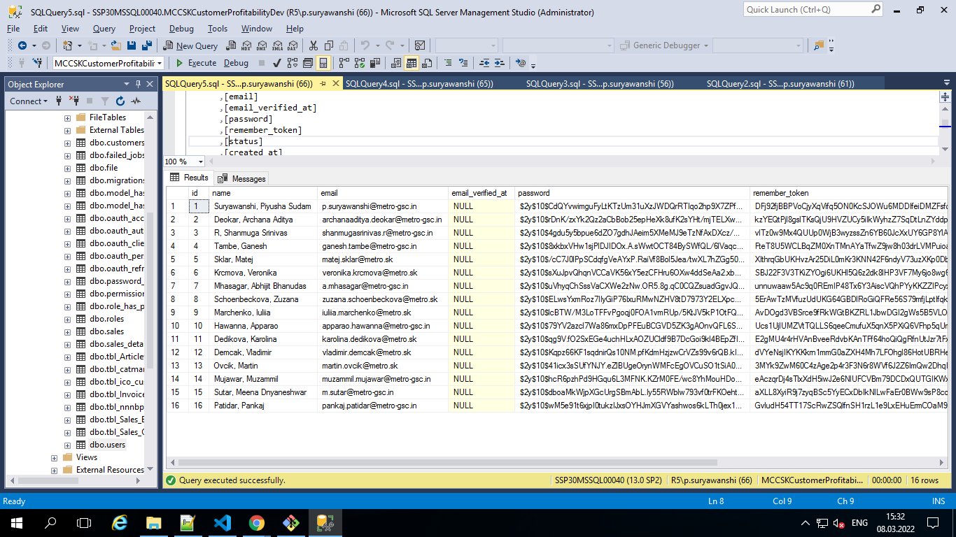

**4) Database:** sqlsrv **DB Name**: MCCSKCustomerProfitabilityDev

**5) MODULES:  
 2.1]** **Login Page**: [**https://lock-in-tool.metro.de**](https://lock-in-tool.metro.de)

**2.2]** **Customers**: [**https://lock-in-tool.metro.de/customer**](https://lock-in-tool.metro.de/customer)

**2.3]** **Offer List Page/ Forecasted OTI Calculations (Back bonus Cal.)**:  
 This screen will be visible only after selecting some articles

**2.4] NNNBP Update**: [**https://lock-in-tool.metro.de/nnnbp_screen**](https://lock-in-tool.metro.de/nnnbp_screen)

**Module Details:  
  
2.1] Login Page:** Login functionality is with IDAM

* **Files:**

**Controller:** F:\xampp\htdocs\profitability-tool\app\Http\Controllers\ SsoController.php

**View:** F:\xampp\htdocs\profitability-tool\resources\views\auth\Login.blade.php

**2.2] Customers / (Filter or Summary Page):** On this page we can filter customers (ico / Linked Customers / Unique Customers) and other parameters to check that particular/selected customer’s summary data.

* **Files:**

**Controller:** F:\xampp\htdocs\profitability-tool\app\Http\Controllers\DashboardController.php

**View:** F:\xampp\htdocs\profitability-tool\resources\views\customer\index.blade.php  
**JS:** F:\xampp\htdocs\profitability-tool\public\js\module-js\customers.js

* **Functions:**  
  **i) OnChange:** on ico change to get linked customers (Using Ajax) => $('select[name="customer_ico"]')  
  **ii) OnClick:** on checkbox click to get all Unique customers (Using Ajax) => $('.refresh_unique')

**iii) OnClick:** on **“**Show Data” button click (used only for year validation/ to add require fields) => $('.show_data')

**iv) OnClick:** on **“**Go to offer list” button click to send user on next page for offer calculations (Using Ajax) => $('#customer-offer’)  
**v) Datatables: :** $('.final_table') **vi) select2 Library:** $('.quater'), $('.customer_unique), $('.category) **vii) Datepicker library:** $('.year_id.from_year '), $('.year_id.to_year ')

* **Store-Procedure Used on Customer Page:  
    
  1) [dbo].[usp_get_article_summary] : To get below Article Listing as per selected Filters   
    
  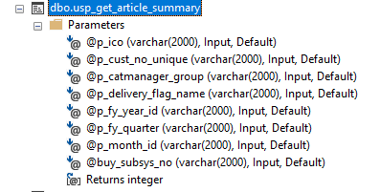**

**2) [dbo].[usp_get_category_share_summary]: To get LHS table of Category Sales share %  
  
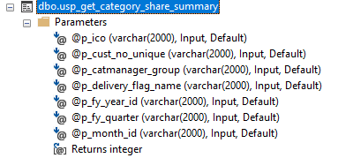  
  
3) [dbo].[usp_get_sales_oti_summary]: To get RHS table of Sales/Quarter - OTI - invoices/month**

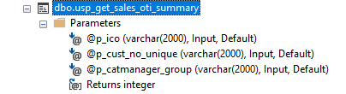

**2.3] Offer List Page/ Forecasted OTI Calculations (Back bonus Cal.):** On this page we calculate the Back bonus (EUR) + Forecasted OTI % of selected ico / Linked Customers / Unique Customers.

* **Files:**

**Controller:** F:\xampp\htdocs\profitability-tool\app\Http\Controllers\DashboardController.php

**View:** F:\xampp\htdocs\profitability-tool\resources\views\customer\offer.blade.php

**JS:** F:\xampp\htdocs\profitability-tool\public\js\module-js\offerlist_oti.js

**NOTE: Offerlist_oti.js:** Flag set/used for Back Bonus calculations   
Flag = 0 (Initial Flag)   
Flag = 2 (Flag for True (success)- to successfully calculates Back Bonus)  
Flag = 3 (Flag for False (Error) – to return false while calculating BB) **s**

* **Functions:**

**i) OnClick:** on “refresh” button click empty the values of Type 1 and Type 2 => $('.refresh_unique')

**ii) OnClick:** on **“**Calculate Backbonus” button click to calculate the back bonus for selected customers => $('. calculate_backBonus')

* check_inputVal() 🡺 function used to validate the input fields like Amount and Percentage fields.
* cal_bb() 🡺 function used to calculate back bonus once above function validate fields or return true.

**iii) OnClick:** on **“**Save” button click from Model to add/remove articles from DB (Using Ajax) => $('#customer-offer’)

**iv) OnClick:** on **“**Calculate OTI” button click to Calculate OTI % for selected cust. (Using Ajax) => $('#calculate’)  
**v) Datatables: :** $('.final_table')

* **Store-Procedure Used on Offer/Forecasted OTI Page:**

1. **[dbo].[usp_get_sales_summary] : To get all sales value as per selected Period(Quarter/Year/customers)  
     
   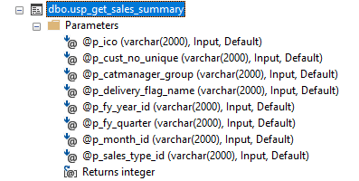**
2. **[dbo].[usp_get_historical_oti] : To get historical sales of selected customers/filters**

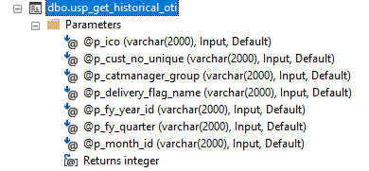

1. **[dbo].[usp_get_nnnbp_value]: To get NNNBP values of selected articles above on offer page**

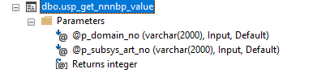

* **Some important points to remember regarding Calculate Back Bonus:**Backbonus = Bonus base * Selected bonus %

Bonus Base is sum of columns containing “Limit & Bonus Base”

Limit Base is sum of columns containing “LimitBase+Limit&BonusBase”

* **Some important points to remember regarding Calculate Forecasted OTI %:**Forecasted OTI % of the basket = [sum(Colli*selling-price) - sum(Colli*nnnbp) - back bonus] / [sum(Colli*selling-price)]

(Here Nnnbp values are getting from above store-procedure “**[dbo].[usp_get_nnnbp_value]**” for each article)

**2.4] NNNBP Update:** On this page we can set net buying price for each buyer’s id.

* **Files:**

**Controller:** F:\xampp\htdocs\profitability-tool\app\Http\Controllers\DashboardController.php

**View:** F:\xampp\htdocs\profitability-tool\resources\views\nnnbp\index.blade.php

**JS:** F:\xampp\htdocs\profitability-tool\public\js\module-js\nnnbp_update.js

* **Functions:**

**i) OnClick:** to change the nnnbp source  
**ii) Datatables: :** $('.nnnbp_table')